Workforce Systems Can Leverage Bank Resources to Improve Economic Self-Sufficiency and Employment Outcomes for

Low- and Moderate-Income Individuals

The Opportunity
Households with an individual with a disability have lower incomes and are more likely to be “unbanked,” meaning that no one in the household has a checking or savings account. Unbanked individuals report that they are often hindered from using banking services by required minimum daily checking balances, poor credit, low availability of bank branches in some communities and other reasons, making them more susceptible to predatory lending practices. Being “banked” is a critical component of financial capability, however, people of color with disabilities are less likely to access traditional banking services than their white counterparts. Furthermore, while working-age people with disabilities are much less likely to be employed than people without disabilities in all racial and ethnic groups, Black families that include a working-age member with a disability experience the lowest rates of employment.
A 1977 federal law called the Community Reinvestment Act (CRA) encourages banks to conduct activities and make investments to benefit low- and moderate-income individuals and neighborhoods, including workforce development-related activities for people with disabilities. CRA activities can take many forms, from the development of financial services career pathways to financial education conducted by bank employees.
We developed this FAQ for workforce development boards and their staff members, community colleges, and others who provide workforce services. It provides answers to the frequently asked questions about workforce system–bank partnerships listed below.
FREQUENTLY ASKED QUESTIONS
What is the Community Reinvestment Act? | What are some examples of partnerships between the workforce system and banks?
What kinds of activities can banks engage in with workforce systems? | What financial education benefits  are possible under the Workforce Innovation and Opportunity Act?
Why focus on people of color with disabilities? | What additional resources can facilitate understanding of and access to the benefits of the Community Reinvestment Act?

What is the Community Reinvestment Act?
Banks receive Community Reinvestment Act credit for participating in and funding activities in low- and moderate-income neighborhoods in the communities in which they conduct business. As determined in the CRA, a low-income community has a median family income that is less than 50% of the area’s median income. A moderate-income community has a median family income that is at least 50% but less than 80% of the area’s median income.
To receive CRA credit for community development, a bank’s strategies must have at least one of the following as its primary purpose:
- Community services targeted to individuals who have a low to moderate income.
- Activities that promote economic development, such as job training or financial education.
- Activities that revitalize or stabilize low- and moderate-income communities.
- Initiatives that create or sustain affordable housing.
All banks have CRA requirements that are based upon their size. Credit unions do not have any requirements under this law, although they can be partners in financial education work.

What kinds of activities can banks engage in with workforce systems to support their CRA requirements and increase career success for individuals?
Banks can engage in a variety of activities with workforce systems to increase career success and financial security for people of color with disabilities, in many cases supporting CRA requirements. Among many other opportunities, these include:
- Teaching financial education, delivering the Federal Deposit Insurance Corporation (FDIC) Money Smart program, or offering financial counseling in workforce development programs.
- Providing donations to workforce development programs designed to improve employment opportunities for low- to moderate-income individuals with disabilities.
- Providing financial capability training to individuals with disabilities.
- Providing volunteer service with nonprofits to provide income tax assistance for low- to moderate-income individuals.
- Serving on workforce boards.
- Helping to establish pipelines of talent to meet the needs of the financial services sector through apprenticeship or other work-based learning.

Why focus on people of color with disabilities?
Indicators such as national employment rates, unemployment rates, and the banking/lending practices of people of color with disabilities signal entrenched structural and other challenges that hinder achievement of economic self-sufficiency. For example, according to an analysis of findings from the 2017 FDIC national survey, people with disabilities have significantly lower rates of employment and higher rates of unemployment than individuals without disabilities. Further, Black and Hispanic families that include a working age member with a disability face lower employment rates than white families with a working age member with a disability.
Exhibit 1: Employment Data
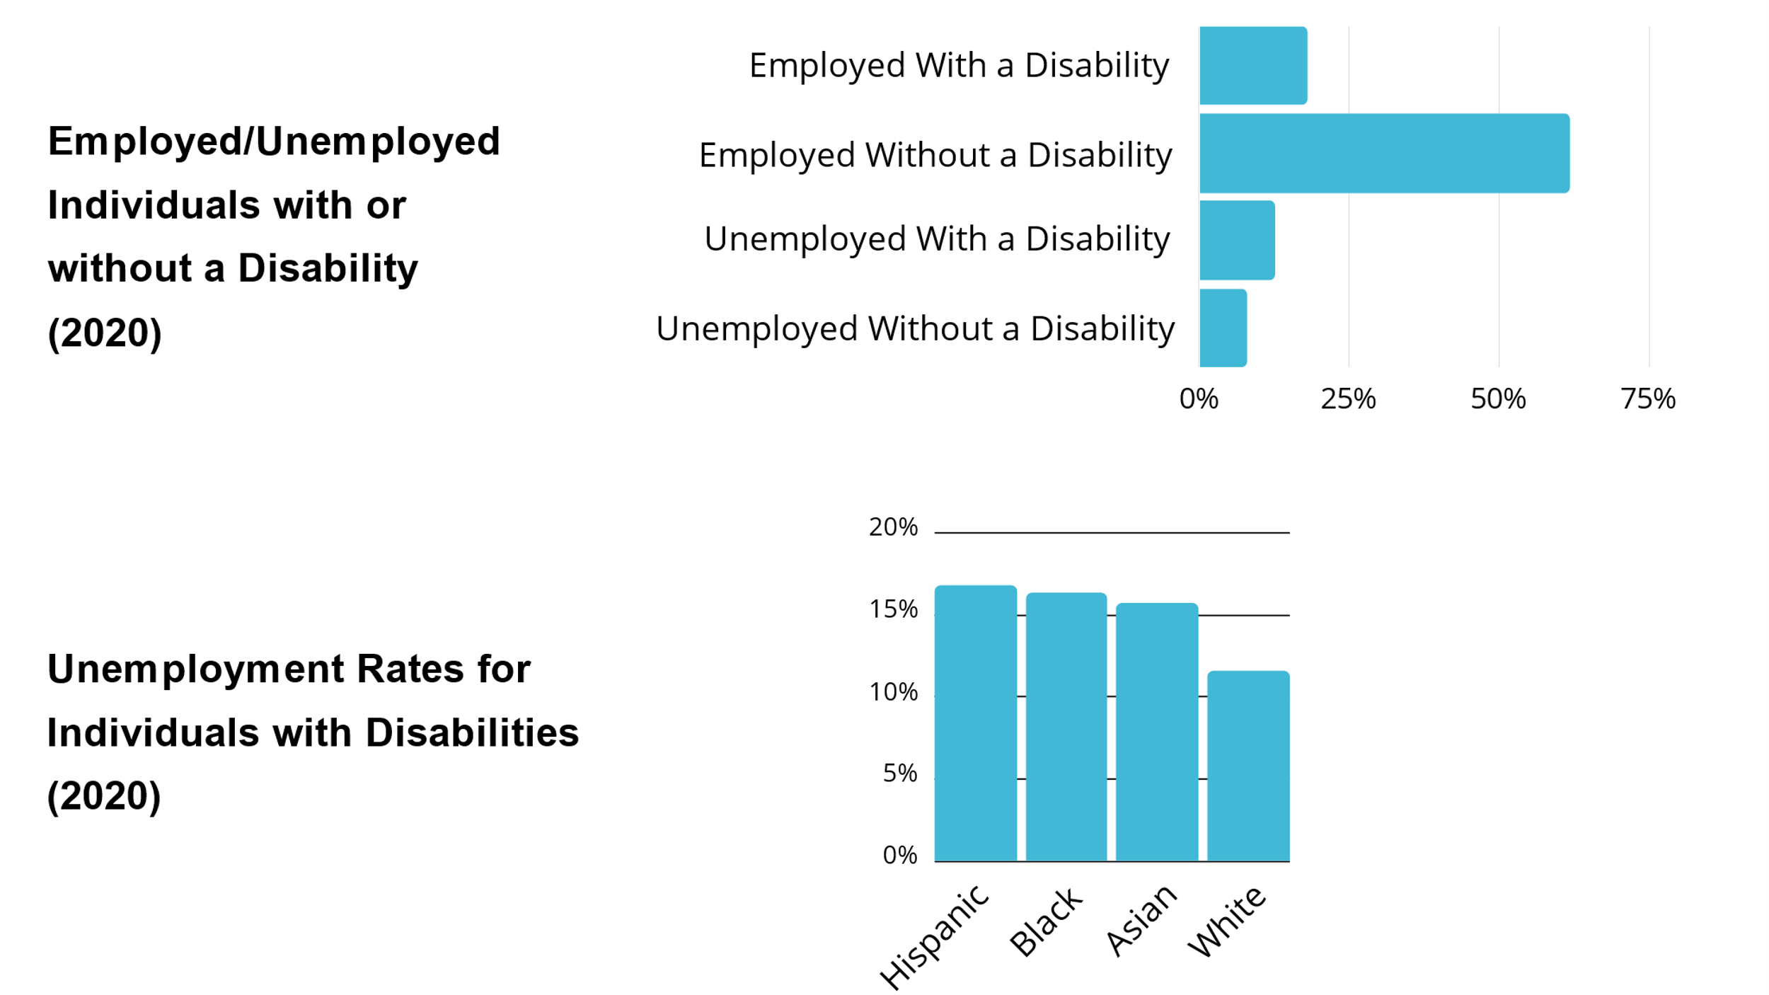

Moreover, working-age households that include a householder with a disability are much less likely to engage with financial institutions. As displayed in Exhibit 2, this is especially true for Hispanic, Black, and Asian working-age households with an individual with a disability.

Exhibit 2: Unbanked Working Age Households (2019)

Data from the same FDIC national survey collected in 2017 showed that, across racial groups, low- and moderate-income individuals with disabilities are more than three times as likely as those without disabilities to be “unbanked” — that is, not have access to or use financial institutions in any capacity. Moreover, one in five has an unmet need for credit. Additionally, predatory “payday” loan companies, which provide high-risk, high-interest loans outside of the banking system, are more likely to market their services to Black and Hispanic people, saddling them with additional debt.

What are some examples of partnerships between the workforce system and banks?
SunTrust Bank with Northern Virginia Career Works and Prince George’s Community College (Virginia and Maryland)
In Virginia and Maryland, SunTrust Bank funded the creation of Financial Empowerment Centers (FECs) that are designed to increase the financial capabilities of low- and moderate-income individuals. SunTrust provided grants through the United Way, which in turn partnered with Virginia Career Works — Northern Region (a local workforce development board) and Prince George’s Community College to establish an FEC at an American Job Center and another on a college campus.
The FECs’ services include one-on-one financial coaching; small business coaching; workshops to address specific financial activities such as banking, saving, and taxes; and tax preparation in partnership with the Internal Revenue Service’s Volunteer Income Tax Assistance. Co-location at an American Job Center and on a college campus allows for a more comprehensive approach to serving customers. The FECs pivoted to offer virtual services once the COVID-19 pandemic began.
The FEC model reflects an investment partnership between banks and the workforce system.
Multiple Banks and Albany-Rensselaer-Schenectady County — Capital Region (Albany, New York)
Since 2001, the Creating Assets, Savings, and Hope (CA$H) Coalition has brought together banks and community-based agencies, including the workforce development board in Albany, New York, to provide programs that increase the financial capabilities of people with disabilities and others in the low- and moderate-income population. The Cities for Financial Empowerment Coalition spearheaded the development of the CA$H Coalition; Wildwood, an area nonprofit agency that is a part of the workforce system, leads it.
Known more widely as “Bank On,” the effort engages job seekers, especially people with disabilities, in:
- Financial capability workshops, where volunteers from banks and credit unions join other professionals to provide training.
- FECs, where staff from financial institutions volunteer and donate resources and strategies, including bank and credit union services.
- Financial coaching, where financial Institutions offer financial wellness one-on-one coaching in their own facilities upon referral.
- Volunteer income tax preparation, where volunteers from the community, including bank employees, with some funding support from the Internal Revenue Service, help people complete their tax returns.
Banks that are part of the Bank On coalition contribute investments and services to the growth of this community.
Multiple Banks and Arapahoe/Douglas Works! (Denver, Colorado area)
The workforce system in Arapahoe and Douglas Counties, Colorado, partnered with Goodwill Industries of Denver in their Bankwork$ program. Bankwork$ provides young adults with training for entry-level positions in banking as well as work experience, coaching, and support with placement into careers in the financial industry. Wells Fargo and Bank of America support this workforce development approach nationally, and the Colorado Bankers Association endorses it. The following local partner banks also participate: U.S. Bank, Bank of America, Bank of the West, Young Americans Bank, KeyBank, Vectra Bank, Bank of Denver, Citywide Banks, and Academy Bank.
The Bankwork$ model is a service and investment partnership between banks and the workforce system.

What financial education benefits are possible under the Workforce Innovation and Opportunity Act?
The Workforce Innovation and Opportunity Act (WIOA) supports the provision of financial education activities for adults and youth and includes specific language intended to improve outcomes for individuals with disabilities and others with multiple challenges to employment. These provisions promote financial empowerment, with the ultimate goal of enabling job seekers to increase their economic self-sufficiency and ability to participate in their communities. Promising career pathways programs also incorporate financial capability training to help people with disabilities successfully manage their finances once they obtain employment.
In WIOA Title I Adult Programs, adult job seekers can participate in financial education activities as appropriate, based on their Individual Employment Plans (IEPs). An IEP indicates the appropriate combination of services a job seeker will receive to meet their employment goals and objectives. This can include skills development to attain career objectives, individual and group counseling, short-term prevocational services, communication and interviewing skills, internships and work experience, as well as financial education services.
The WIOA Title I Youth Program includes financial literacy education as one of 14 services that must be available to youth participants. WIOA youth financial education provides youth with the skills and knowledge they need to achieve long-term financial stability. In Section 129 of WIOA, these skills and knowledge include making and using budgets, saving, planning effectively for education and retirement, and using credit as well as financial products and services effectively.

What additional resources can facilitate understanding of and access to the benefits of the Community Reinvestment Act?
Center for Disability-Inclusive Community Development (CDICD) nationaldisabilityinstitute.org/disability-inclusive-community-development
The CDICD works to improve the financial health and well-being of low- and moderate-income individuals with disabilities and their families by increasing awareness and usage of the opportunities and resources available under the CRA.
In its webinar, Workforce Development and Meeting Obligations Under CRA, the CDICD explores how the CRA can support workforce development outcomes for people with disabilities. The webinar presents an overview of the CRA and its connection to workforce development followed by a discussion of how partnerships can be developed and strengthened from the perspective of an organization serving people with disabilities and the perspective of a bank partner.

“Hands On Banking” Quick-Reference Guides and Disability Supplemental Guides
nationaldisabilityinstitute.org/resources/hob-qrg-and-supplemental-guides
Hands On Banking quick-reference guides provide information and resources that cover 15 different barriers that individuals may experience. The disability supplemental guides cover disability sensitivity and information to complement the Hands On Banking instructor guides for adults, young adults, and entrepreneurs. Subjects include employment, money management, protected savings, work supports and other financial capability topics relevant to people who have disabilities. These guides also provide numerous tips, tools, resources and links to Hands On Banking materials.

Banks’ Community Reinvestment Act (CRA) Opportunities for Promoting Job Creation, Workforce Development, and Place-Based Investments
philadelphiafed.org/community-development/credit-and-capital/banks-community-reinvestment-act-opportunities
This report, published by the Federal Reserve Bank of Philadelphia in October 2017, summarizes innovative activities from banks’ CRA performance evaluations in the areas of job creation, education, workforce development, transportation and affordable housing. It highlights real-world situations in which banks received CRA credit in these areas to promote economic growth and prosperity in their communities.

Goodman, N., & Morris, M. (2019). Banking Status and Financial Behaviors of Adults with Disabilities: Findings from the 2017 FDIC National Survey of Unbanked and Underbanked Households and Focus Group Research. National Disability Institute.
Ibid.
Ibid.
Goodman, N., & Morris, M (2017). FINANCIAL INEQUALITY: Disability, Race and Poverty in America. National Disability Institute.
Community Reinvestment Act, 12 U.S.C. § 2901 et seq.; 12 C.F.R. § 25.04.
Federal Reserve Bank of Dallas & Federal Reserve Bank of Kansas City (2016). Engaging Workforce Development: A Framework for Meeting CRA Obligations.
CRA Newswire (2018, June 25) Ever Wondered “What is Low- and Moderate-Income or LMI?” Here’s Your Answer.
Ibid.
Goldstein, S & Ding, L Federal Reserve Bank of Philadelphia (2017). Banks’ Community Reinvestment Act (CRA) Opportunities for Promoting Job Creation, Workforce Development, and Place-Based Investments.
Community Reinvestment Act, 12 C.F.R. § 25.04(c).
Goodman, N., & Morris, M. (2019). Banking Status and Financial Behaviors of Adults with Disabilities: Findings from the 2017 FDIC National Survey of Unbanked and Underbanked Households and Focus Group Research.
Bureau of Labor Statistics. (2021, February 26). Persons with a disability: Labor force characteristics – 2020 [Press release]. U.S. Department of Labor.
Ibid.
A “householder”refers to: 1) the person (or one of the people) in whose name the housing unit is owned or maintained, and (2) someone who specified that they had some level of participation in their household finances. Federal Deposit Insurance Corporation. (2020, October). How America banks: Household use of banking and financial services—2019 FDIC survey.
Analysis of 2019 FDIC Survey of Household Use of Banking and Financial Services. National Disability Institute. Data sets can be found at: https://www.economicinclusion.gov/downloads/index.html#yearly.
Goodman, N., & Morris, M. (2019). Banking status and financial behaviors of adults with disabilities: Findings from the 2017 FDIC National Survey of Unbanked and Underbanked Households and focus group research. National Disability Institute.
Lazarus, D. (2021, April 9). There’s a racial gap in marketing by banks and payday lenders, study finds. Los Angeles Times.
Workforce Innovation and Opportunity Act (WIOA), 29 U.S.C. § 3101 et seq.

